|  |
| --- |
| Baker |
| Project files, $123 million |

Wednesday, November 14 2018

# Brigett Hurley

Time management tools to create a spreadsheet using applications in a movie for Baker Project Files. Store information on beginning project with data in numbers. Categories for each file. The files are saved on Cloud and can be converted to other types of files. This project file is on Word document.



## Bakery Story Baker Project Files

Photos, Sketcher and Project tools. Locations in Los Angeles, New York and Paris. Café Restaurant small but quick service.



Figures can relate to costs. The costs could include Accounting, Quickbooks, Administration, Surveys, Rewards, memberships and get together. The group of at least five to oversee data analytics on business. Three person in a group, and one person from group on project files. A board of 10 person with three on proposals for project files.

Brown : I want to discuss a white board meeting.

Stamford: A nice general ledger and ideas.

Brown: A idea on a general ledger and a white board meeting between Stamford and Brown. One person included.

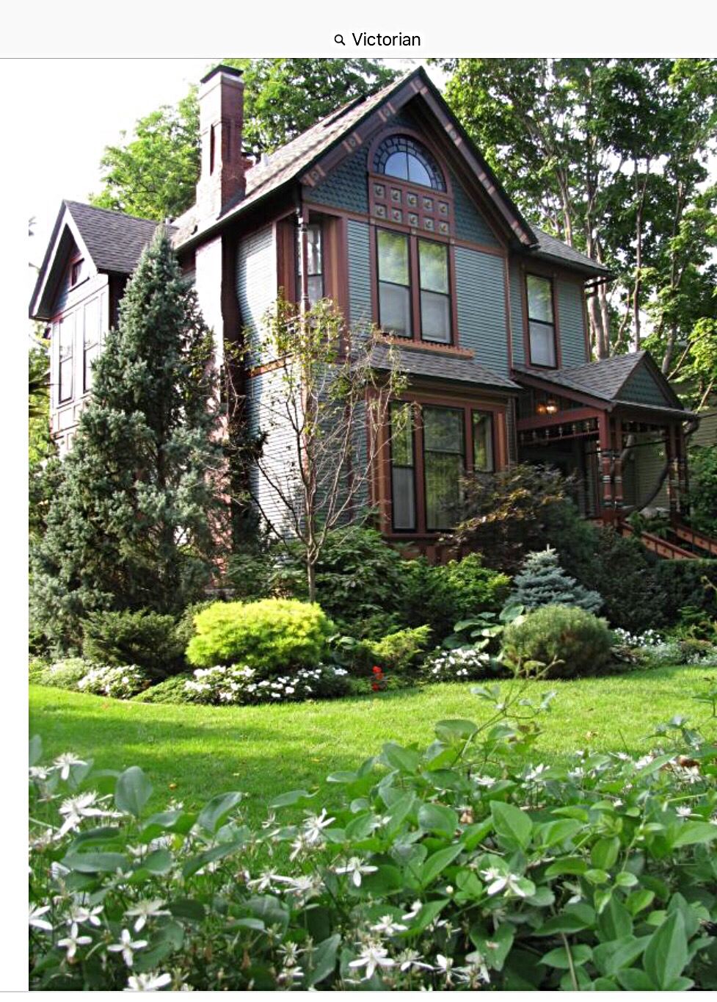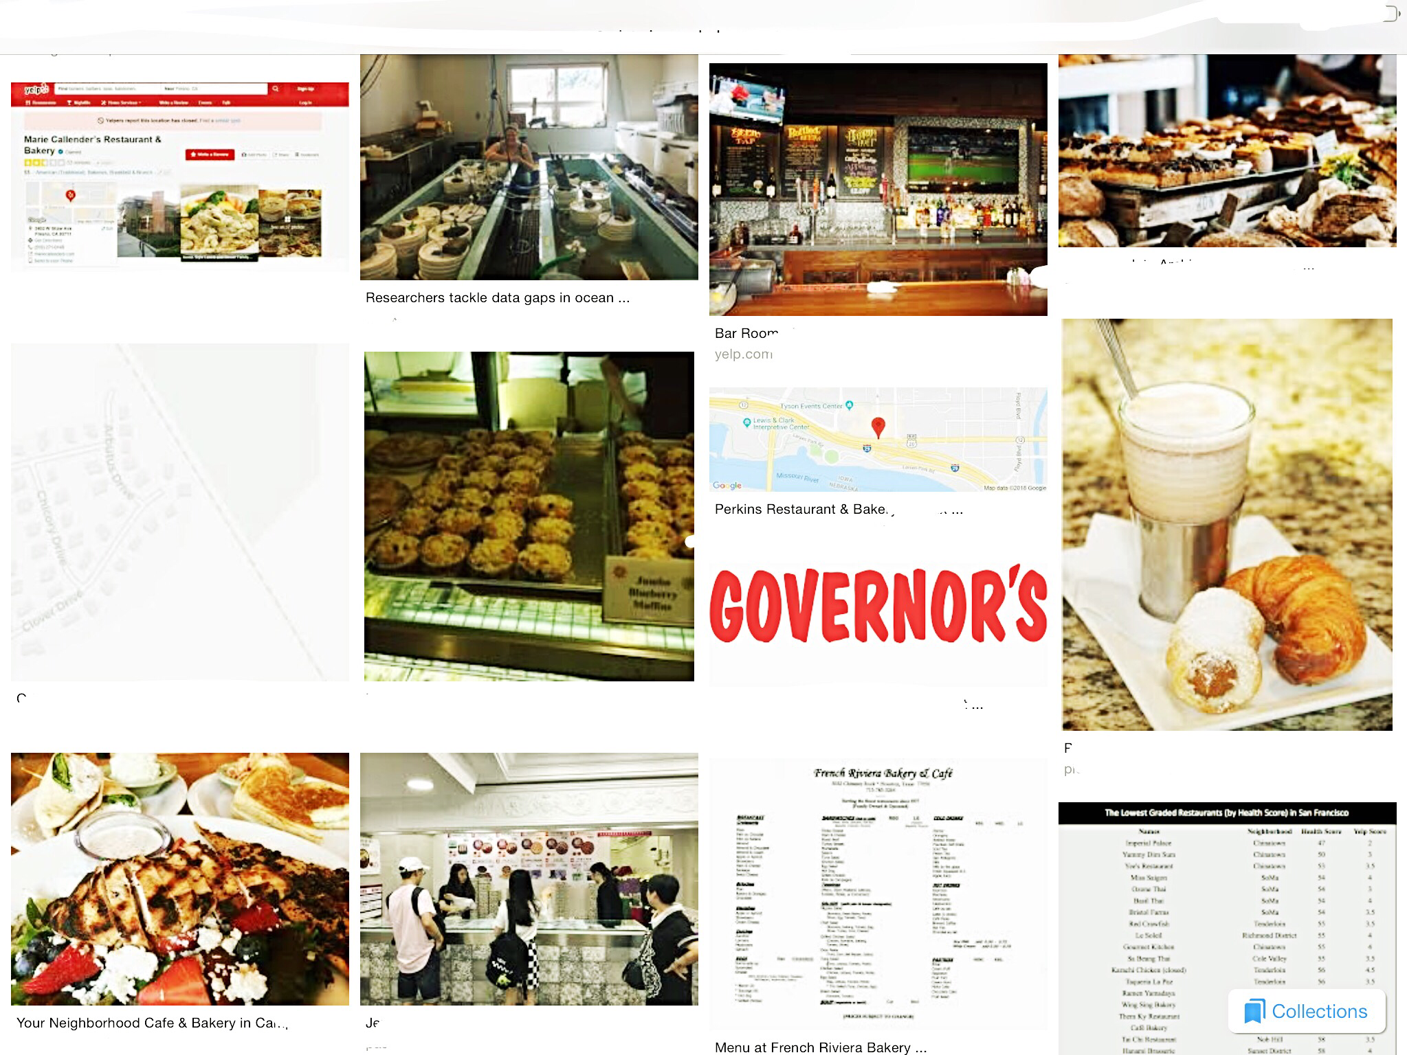The project files movie. Baker is a small café restaurant with bakery and foods that are warm and creamy. Plenty of fruit preserved made with lots of varied breads in dishes of Victorian and roses. In a today modern technology fast pacing world. Any place, Anywhere, and Anytime.

Sketch



